ModTech International Conference - New face of TMCR (11pt)
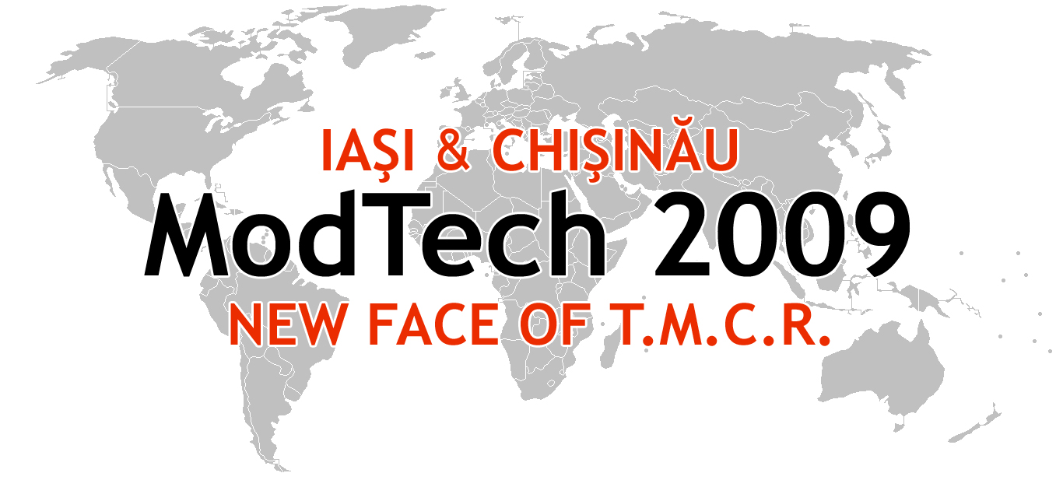

Modern Technologies, Quality and Innovation - New face of TMCR (11pt)
21-23th May 2009 (11pt)
¶ (10 pt)
¶ (10 pt)
¶ (10 pt)
¶ (10 pt)
instructions for authors and a sample paper
(14 pt bold with capital letters, two lines max.)
¶ (10 pt)
Dumitru Nedelcu¹, Octavian Pruteanu¹ & Catalin Fetecau² (12 pt bold)
¶ (10 pt)
¹Technical University “Gheorghe Asachi” of Iasi-Romania, Department of Machine Manufacturing Technology
² Technical University “Dunarea de Jos” of Galati, Department of Machine Manufacturing Technology (10 pt)
¶ (10 pt)
Corresponding author (who upload the abstract): Octavian Pruteanu, pruteanu@tcm.tuiasi.ro (10 pt)
¶ (12 pt)

Abstract: Abstract of 100-150 words (10 pt) y yyy yyy yyy
yyy yyy yyy yyy yyy yyy yyy yyy yyy yyy yyy yyy yyy y
yyy please use second-name_first-name (of first author)-A-abstract-number.doc for abstract file upload (Nedelcu_Dumitru-A1.doc; Nedelcu_Dumitru-A2.doc) yyy yyy yyy yyy yyy yyy yyy yyy yyy yyy yyy yyy yyy yyy yyy yyy yyy yyy yyy yyy yyy yyy yyy yyy yyy yyy yy
Key words: List 5-6 keywords (10 pt).
¶ (10pt)
1. Introduction (12 pt, capitals, bold)
¶ (10pt)
The paper must be written in English. Each paper is compulsory to respond of following questions:
Which is the actual state of the problem?
What is done at international level?
Which is the originary main idea of your paper?
Which is the research methodology used in your paper?
Which are the main results of your paper and application areas?
Which are the main steps to develop your research in the future?
¶ (10pt)
2. GENERAL information
¶ (10pt)
2.1 Layout (11 pt, bold)
The paper has to be written in doc format.
Please use the A4 Format (297 x 210 mm); Margins: top, bottom, right 15 mm each and left 20 mm; 2 columns, column distance 7 mm.
The paper is restricted to exactly four full A4 pages.
Please use Times New Roman fonts, line spacing single. The font formats are: paper title: 14 pt bold, capital letters; author's name(s): 12 pt bold; key words: 10 pt; chapter titles: 12 pt bold, capital letters left justified; subtitles: 11 pt bold, numbered, left justified, upper and lower case; text: 11 pt.
Please use second-name_first-name (of first author)-P-paper-number.doc for paper file upload (Nedelcu_Dumitru-P1.doc; Nedelcu_Dumitru-P2.doc).
Yyy yyy yyy yyy yyy yyy yyy yyy yyy yyy yyyy yyy yyy yyy yyy yyy yyy yyy yyy yyy yyy yyy yyy yyy
3. Figures ACHIEVEMENT
¶ (10pt)
The figures have to be made in high quality, which is suitable for reproduction and print. Please don't include the colour photos. Please place the figures as close as possible to their first reference in the paper.
¶ (10pt)

The figures could be also made using the both columns space, if necessary

Fig. 1. Title of figure, centred, [number of the references].
¶ (10pt)
4. TABLES ACHIEVEMENT
¶ (10pt)
Please place the tables as close as possible to their first reference in the paper.
¶ (10pt)
Table 1. Title of table, centred, [number of the references].
The tables could be also made using the both columns space, if necessary
¶ (10pt)
5. equations ACHIEVEMENT
¶ (10pt)
Please align the equations centred and numbered consecutively, from 1 upwards, as follow:
¶ (10pt)
f=∑r_{i}/∑t_{i}r_{i} (11pt) (1)
(The equations could be also made using the both columns space, if necessary).
¶ (10pt)
6. Referring PROCESS
¶ (10pt)
Please use the following instructions:
-for one author, use the author’s surname and the publication year (Coelho, 2006);
-for two authors, give both names & the publication year (Sevasti & Bouzakis, 2007);
-for three or more authors, use the first author, plus „et al.“, and the publication year (Toca et al., 2007).

7. CORRESPONDING addresses
¶ (10pt)
For any type of problems please contact us on the following email address: ccarausu@tcm.tuiasi.ro (associate professor Constantin Carausu); pereueugen@yahoo.com (lecturer Pereu Eugen) always we’ll have a solution to any of your problems.
Please check the http://www.modtech.ro for all informations.
¶ (10pt)
8. ModTech CONFERENCE pAPERS
¶ (10pt)
Accepted papers will be published in ModTech2009 Proceedings. The organizing committee agreed to start the process of indexing the conference proceedings in the “ISI Web of Knowledge” ISI Proceedings Database. You can find more information about ISI Proceedings at http://scientific.thomson.com/products/proceedings.
Selected papers (no more 8-12) will be published as a special issue of the International Journal of Mechatronics on Manufacturing Systems (IJMMS). You could find more information about IJMMS Inderscience Journal at http://www.inderscience.com/browse/index.php?journalID=239
¶ (10pt)
9. CONFERENCE publishing steps
¶ (10pt)
Step 1: Please make your own account (register to ModTech) on http://www.modtech.ro
Step2: Please upload your abstract to your ModTech-Account (http://www.modtech.ro/). Please use second-name_first-name (of first author)-A-abstract-number.doc for abstract file upload (Nedelcu_Dumitru-A1.doc; Nedelcu_Dumitru-A2.doc)
Step 3: Please wait on the Results of Abstract Review.
Step 4: Please upload your finished paper to your ModTech-Account (http://www.modtech.ro/). Please use second-name_first-name (of first author)-P-paper-number.doc for paper file upload (Nedelcu_Dumitru-P1.doc; Nedelcu_Dumitru-P2.doc).
Step 5: Please wait on the Results of paper Review.
Step 6: Please correct your paper according to the Results of Review.
Step 7: Please upload your corrected paper to your ModTech account. Please take into account that only the papers which are accepted will be prepared for publishing and presentation at the Conference, if the fee has been paid.
Please use second-name_first-name (of first author)-P-paper-number-FINAL.doc for FINAL paper file upload (Nedelcu_Dumitru-P1-FINAL.doc; Nedelcu_Dumitru-P2-FINAL.doc).
Step 8: Please wait for the announcement of the ModTech International Conference program and instructions for the oral presentation of the paper.
Step 9: Please don’t forget to prepare for participation to the ModTech International Conference-New face of TMCR.
Step 10: Have a nice trip to ModTech International Conference-New face of TMCR!
Please take into account that those papers which are not prepared exactly according to the instructions and the template will not be accepted, and not published in ModTech Procedings.
¶ (10pt)
9. LANGUAGE AND STILE SPELLING
¶ (10pt)
Please use common technical terms and right English words.
Please follow Merriam Webster’s Collegiate Dictionary, Longman or Oxford Dictionaries for unknown terms.
¶ (10pt)
10. ConclusionS
¶ (10pt)
Please read carefully these instructions for authors.
Also please prepare your paper according to the instructions because we consider that it is the easiest way to have a good published paper, clear presentation and a successful ModTech International Conference. We are looking forward to meet you in Chisinau in May 2009!
¶ (10pt)
11. References
¶ (10pt)
Please include at least 5 items and have them left aligned. The list of references has to be arranged alphabetically according to the first author, subsequent lines intended. Please place the number of references. Publications by the same author(s) should be listed in order of year of publication. Please take into consideration that all references listed here is compulsory to be directly cited in the body of the text. Please don’t use the own quatations.
¶ (10pt)
1. Carausu, C.; Hassan, A. & Chueco, J.R. (2006). Name of Paper, Available from: http://www.exact-address-of-site, Accessed: dd/mm/yyyy.
2. Coelho, A. (2006). Name of paper. Name of Journal in Italics, Vol., No., (month and year of the edition) page numbers (first-last), ISSN........
3. Dohotaru, I.; Gramescu, T. & Zagan, R. (2005). Title of conference paper, Proceedings of xxx xxx, Katalinic, B. (Ed.), pp. 14-17, ISBN, conference location, month and year, Publisher, City
4. Sevasti, M. & Bouzakis, D. (2007). Name of paper, In: Name of Book in Italics, Name(s) of Editor(s), (Ed.), page numbers (first-last), Publisher, ISBN, Place of publication
5. Toca, A.; Carausu, C. & Merticaru, V. (2007). Name of Book in Italics, Publisher, ISBN, Place of Publication

