CONFERENCE COMMITTEE
HONORARY CHAIRS:
Acad.dr.Hab.Prof.univ. Ion Bostan, Rector Technical University of Moldova.
Prof.univ.dr.ing. Ion Giurma, Rector Technical University “Gheorghe Asachi” of Iasi-Romania
CHAIRS:
Prof.univ.dr.ing. Laurentiu Slatineanu, Head of Department of Machine Manufacturing Technology, Faculty of Machine Manufacturing and Industrial Management, Technical University “Gheorghe Asachi” of Iasi-Romania
Prof.univ.dr.ing. Sergiu Mazuru, Head of Department of Machine Manufacturing Technology, Faculty of Engineering and Management in Machine Manufacturing, Technical University of Moldova.
CO-CHAIRS:
Prof.univ.dr.ing.ec. Dumitru Nedelcu, Department of Machine Manufacturing Technology, Faculty of Machine Manufacturing and Industrial Management, Technical University “Gheorghe Asachi” of Iasi-Romania
Assoc.Prof. Ion Rusica Department of Machine Manufacturing Technology, Faculty of Engineering and Management in Machine Manufacturing, Technical University of Moldova.
SCIENTIFIC COMMITTEE
Eugen AXINTE, UT Gh. Asachi Iaşi, România
Doru BARDAC, U Politehnica Bucureşti, România
Ion BOSTAN, UT a Moldovei, Chişinău, Moldova, Honorary Chair
Nicolae BÂLC, U Tehnică Cluj-Napoca, România
Vasile BEJAN, Universitatea Transilvania Braşov, România
Florin BLAGA, U Oradea, România
Cazimir BOHOSIEVICI, UT Gh. Asachi Iaşi, România
Gheorghe BRABIE, U din Bacău, România
Paul Dan BRÂNDAŞU, ULB Sibiu, România
Andrzej BUCHACZ, Silesian UT, Gliwice, Polonia
Marian BUNEA, ATM Bucureşti, România
Tudor CHERECHES, ATM Bucureşti, România
Francisco CHINESTA , Ecole Centrale Nantes, France
Mircea CIOBANU, U Ştefan cel Mare Suceava, România
Mircea COZMINCĂ, UT Gh. Asachi Iaşi, România
Calin DENES, U of Sibiu, Romania
Mircea Viorel DRAGOI, U Brasov, Romania
Marc GABRIEL, ESSTI Nancy, Franţa
Jan GAVRILA, ATM Bucureşti, România
António GONÇALVES-COELHO, U Nova de Lisboa, Portugalia
João Paulo DAVIM, University of Aveiro, Portugal
George DRAGHICI, U Politehnica Timişoara, România
Mircea Viorel DRAGOI, U Transilvania Braşov, România
Valeriu DULGHERU, UT a Moldovei Chişinău, Moldova
Cristian DOICIN, UP Bucureşti, România
Cătălin FETECAU, U Dunărea de Jos Galaţi, România
Marian GHEORGHE U Politehnica Bucureşti, România
Ion GIURMA, UT Gh. Asachi Iaşi, România, Honorary Chair
Mihai GOANTA, U Braila, Romania
Traian GRĂMESCU, UT Gh. Asachi Iaşi, România
Stepan HRISTOFOREAN ,UTS, Armenia
Huran LIU, Zhejiang University of Science and Technology, China
Octavian LUPESCU, UT Gh. Asachi Iaşi, România
Alexandru EPUREANU, U Dunărea de Jos Galaţi, România
Romeo IONESCU, U Ştefan cel Mare Suceava, România
Nicolae-Valentin IVAN, U Transilvania Braşov, România
Tudor Iclanzan, U Politehnica Timişoara , România
Constantin ISPAS, U Politehnica Bucureşti, România
Vasile KRIVŢOV, U Michigan, SUA
Alexandru LUCICIOV, UTN Donetsk, Ucraina
Peter LORENZ, University of Applied Sciences Saarbrücken, Germania
Nouraş LUPULESCU, U Transilvania Braşov, România
Vasile MAMALIGA, UT a Moldovei Chişinău, Moldova
Alexandr MALIARENCO, UTN, Belarus
Sergiu MAZURU, UT a Moldovei Chişinău, Moldova, Chair
Alexandru MIHAILOV, UTN Donetsk, Ucraina
Sevasti MITSI, U Aristotelis Salonic, Grecia
Gheorghe MOGAN, U Transilvania Braşov, România
Gavril MUSCĂ, UT Gh. Asachi Iaşi, România
António MOURÃO, U Nova de Lisboa, Portugal
Gheorghe NAGÎŢ, UT Gh. Asachi Iaşi, România
Ilia NAVCA, UTN Donetsk, Ucraina
Dumitru NEDELCU, UT Gh. Asachi Iaşi, România, Co-Chair
Dorian CHIROŞCA, AGEPI, Moldova
Nicolae OANCEA, U Dunărea de Jos Galaţi, România
Constantin OPREAN, U Lucian Blaga Sibiu, România
Viorel PAUNOIU, U Dunărea de Jos Galaţi, România
Octavian PRUTEANU, UT Gh. Asachi Iaşi, România, Honorary Chair
Vladimir PROSEANIC, Ideation International Inc., S.U.A.
Ion RUSICA, UT a Moldovei Chişinău, Moldova, Co-Chair
Doru-Gheorghe SAFTA, Military Academy, Bucharest, Romania
Loredana SANTO, U Tor Vergata Roma, Italia
Francisco SANTOS, U Valladolid, Spain
Halina SETLAK, U Tehnologică Rzeszow, Polonia
Laurenţiu SLATINEANU, UT Gh. Asachi Iaşi, România, Chair
Dănuţ SOSDEAN, U Politehnica Timişoara, România
Anatolii SUSLOV, UT Briansk, Rusia
Dmitry TANANKO, Ford Motor, S.U.A
Victor TARANENCO, Politechnica Lubelska, Polonia
Alexei TOCA, UT a Moldovei, Chişinău, Moldova, Honorary Chair
Pavel TOPALA, U Alecu Russo, Balti, Moldova
Aurelian VLASE, U Politehnica Bucureşti, România
Remus ZAGAN, U Ovidius Constanta, Romania
Vasile ZAMFIR, U Petroşani, România

Technical University “Gheorghe Asachi” of Iasi
Romania
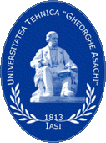

Technical University of Moldova
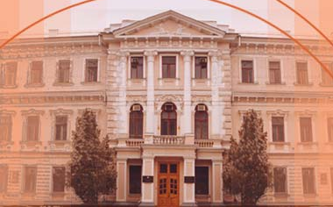

Ministry of Research and Education
Romania

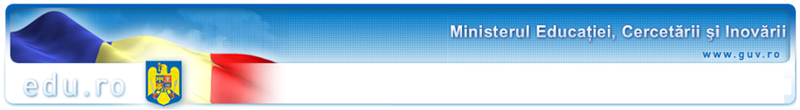
Ministry of Research and Education
Moldova



Department of Machine Manufacturing Technology of Iasi-Romania
Department of Machine Manufacturing Technology of Kishinev -Moldova

ModTech 2009

13th International Conference

Modern Technologies, Quality and Innovation
New face of TMCR
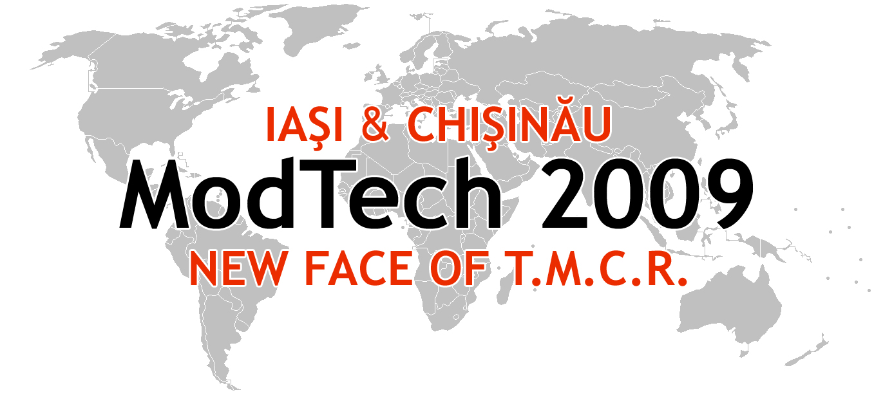

ModTech 2009

Second
CALL FOR PAPERS

May, 21-23th, 2009

Chisinau - Moldova
Iasi – Romania

SHORT HISTORY ModTech2009-New face of TMCR

The first edition of the International Conference “Modern Technologies in Machine Manufacturing Technology-TMCM” was organized in 1995. From 1999, since the organizing agreement in common by the Departments of Machine Manufacturing Technologies of the Technical University “Gheorghe Asachi” from Iasi and Technical University of Moldova from Kishinev, the Conference changed its name in “Modern Technologies, Quality, Reorganization-TMCR”, which took place each year successively at Iasi and Kishinev. Beginning with present edition, the 13th, the name of the Conference will be “Modern Technologies, Quality and Innovation-ModTech”-New face of TMCR. In the 12 preceding editions there have been published, yearly, over 250 scientific papers in 4-5 volumes with authors over 25 countries from Europe, SUA and Asia.

SUBMISSION OF ABSTRACTS AND FULL PAPERS

First of all please follow the steps from new template for paper available on web site of Conference, http://www.modtech.ro (News).
All the papers will be evaluated by two reviewers.
It’s compulsory that the authors of accepted papers would be required to sign a copyright transfer to the organizers committee by fax to 0040.232.217290 or email: ccarausu@tcm.tuiasi.ro
Accepted papers will be published in ModTech2009 Proceedings. The organizing committee agreed to start the process of indexing the conference proceedings in the “ISI Web of Knowledge” ISI Proceedings Database. You can find more information about ISI Proceedings at http://scientific.thomson.com/products/proceedings.
Selected papers (no more 8-12) will be published as a special issue of the International Journal of Mechatronics on Manufacturing Systems (IJMMS). You could find more information about IJMMS Inderscience Journal at http://www.inderscience.com/browse/index.php?journalID=239

IMPORTANT DEADLINE

Submission of the abstract: February, 12th 2009
Notification of the abstract acceptance: February 14th, 2009
Submission of the full papers: March 15th, 2009
Notification of full papers acceptance: April, 5th, 2009
Submission of the final paper: April, 30th, 2009.

VENUE

The ModTech2009 International Conference will take place in Chisinau- Moldova. You can find more information at http://www.modtech.ro.

CONFERENCE TOPICS

✓ Micro and Nanotechnology
✓ Rapid prototyping technologies
✓High speed manufacturing processes
✓Ecological technologies in machine manufacturing
✓Manufacturing and Automation
✓Flexible manufacturing
✓New manufacturing processes: design, control and exploitation
✓Assembly and Disassembly
✓Cold forming technologies
✓Optimization of experimental research and manufacturing processes
✓ Maintenance, reliability, life cycle, time and cost
✓CAD/CAM/CAE/CAX Integrated Systems
✓New software in Engineering
✓Learning and education in Engineering
✓Composite materials technologies
✓Concurrent Engineering
✓Non-conventional technologies
✓Virtual Manufacturing
✓Innovation, Creativity and Industrial Development
✓Projects management
✓Quality Systems Assurance
✓Intelligent Manufacturing Systems
✓Welding technologies
✓Industrial design
✓Gear Design and Technology
Other related topics could be included in the final program of the ModTech International Conference.

REGISTRATION

Before /after May 1st, 2009
- 50€ (incl. VAT)/author or coauthor participant
- 40€ (incl. VAT)/accompanying person
-10€ (incl. VAT)/second paper.
The registration closes on May 10th, 2009.
Fee includes access to all technical sessions, poster and
industrial exhibition, welcome reception, gala dinner,
coffees/lunches. Also includes the volumes of the conference.
Please take into account that all the papers will be excluded from the proceedings if the registration fee are not received by May 10th, 2009.

PARALLEL EVENTS
Several workshops, art exhibitions and outreach activities thematically linked to the theme of the conference, as well as poster exhibition will accompany the main conference in Chisinau. An award for the best young scientist taking part in the poster exhibition will be organized. Moreover, a series of lectures targeting young people will demonstrate the potential applications of modern technologies and their impact. Also a job-shop will be included for the young researches.

INDUSTRIAL EXHIBITION
The conference will also be accompanied by a special industrial exhibition demonstrating different ways of implementing modern technologies knowledge into industrial products. The exhibition will cover areas such as: micro and nanotechnology, rapid prototyping technologies, CAD/CAM/CAE/CAX, high speed manufacturing processes, non-conventional technologies, and composite materials. The conference will be also open to host exhibits of new and innovative concepts and services for responsible and sustainable development of modern technologies.

ORGANIZERS
✓ Technical University “Gheorghe Asachi” of Iasi-Romania, Department of Machine Manufacturing Technology, Faculty of Machine Manufacturing Technology and Industrial Management.

✓ Technical University of Chisinau-Moldova, Department of Machine Manufacturing Technology.

The Conference has the support of the Romanian Ministry of Education and Research and Moldova Ministry of Education and Research.

CONFERENCE SECRETARIAT
ModTech 2009 Secretariat, Romania:
Contact person: associate prof. Constantin Carausu, Ph.D.,
Tel-Fax: 0040.232.217290; Email: ccarausu@tcm.tuiasi.ro
Web page: http://www.modtech.ro
ModTech 2009 Secretariat, Moldova:
Contact person: lecturer Pereu Eugen, Ph.D.,
Tel. +373.22.509944, Fax:+373.22.509950;email: pereueugen@yahoo.com
Web page: http://www.modtech.ro

PARTICIPATION CONDITIONS
In order to be admitted to any of the Conference sections and activities and to get the published Conference Proceedings, each participant will pay, at the same time with the full papers submission, a participation fee in the following account (mention “Participation ModTech 2009-New face of TMCR”):
Republic of Moldova: Bank Correspondent Commerzbank, Frankfurt am Main, Germany, Swift cobadeffxxx bank account n 400887008101 eur for banca sociala, 237470300004774, Moldova, Swift bsocmd2xxxx in favor of Mazuru Sergiu ACC 237470300000774/237470300004774
Romania: Dodun-des-Perrieres Oana,
Account no (EUR): RO20BRDE240SV38875222400,
Romanian Bank for Development, Groupe Société Générale
1-7, Ion Mihalache Street, Sector 1, cod 011171
Bucharest, Romania,
Swift Code: BRDEROBU
Account no (RON): RO82BRDE240SV50588672400
Banca BRD, Sucursala Iasi.

Mailing Address:
✓ Technical University of Moldova, Department of Machine Manufacturing Technologies, Str. Studenţilor, Nr.9, Corp 6, Republic of Moldova, Chisinau, 2004, Bd. Ştefan Cel Mare, 168, Tel.: +373 2 44.53.03, Fax +373 2 44 73 38, e-mail s_mazuru@mail.utm.md
✓ Technical University „Gheorghe Asachi” of laşi-Romania, Department of Machine Manufacturing Technologies, Bd Dimitrie Mangeron 63, IASI-6600, Tel +40 232 21 72 90, Fax +40 232 21 72 90, e-mail: slati@tcm.tuiasi.ro

ORGANIZING COMMITTEE
✓ Technical University “Gheorghe Asachi” of Iasi-Romania
Assoc.prof. Constantin Carausu, Assoc.prof. Oana Dodun, Assoc.Prof. Lucian Tabacaru, Assoc.prof. Vasile Merticaru, Assoc. Prof. Viorel Cohal, Assoc.Prof. Laurentiu Ghenghea, Lecturer Ciprian Ciofu, Lecturer Florin Negoescu, Assit. Margareta Coteata, Assist. Adrian Iosub, Ph.D. Student Ramona Popa, Ph.D. Student Ionut Popa, Ph.D. Student Ovidu Sava.
✓Technical University of Moldova
Lecturer Pereu Eugen, Assoc.Prof. Ion Dohotaru, Assoc.Prof. Victor Moraru, Lecturer Sochirianu Anatol, lecturer Ciperca Rodion, Lecturer Maxim Vaculenco, Assist. Mardar Alexandru

