ModTech International Conference - New face of TMCR (11pt)
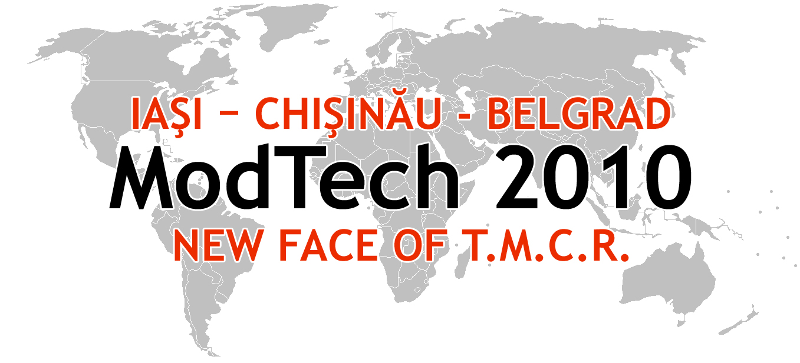

Modern Technologies, Quality and Innovation - New face of TMCR (11pt)
20-22th May, 2010 (11pt)
¶ (10 pt)
¶ (10 pt)
¶ (10 pt)
¶ (10 pt)
instructions for authors and a sample ABSTRACT
(14 pt bold with capital letters, two lines max.)
¶ (10 pt)
First Name Surname¹, First Name Surname ¹ & First Name Surname ² (12 pt bold)
¶ (10 pt)
¹Technical University “Gheorghe Asachi” of Iasi-Romania, Department of Machine Manufacturing Technology
² Technical University “Dunarea de Jos” of Galati, Department of Machine Manufacturing Technology (10 pt)
¶ (10 pt)
Corresponding author (who upload the abstract): First Name Surname, E-mail address (10 pt)
¶ (12 pt)
Abstract (TNR 10pt, bold, italic): The abstract must have 100-150 words (10 pt) y yyy yyy yyy yyy yyy yyy yyy yyy yyy yyy yyy yyy yyy yyy yyy yyy yyy yyy yyy yyy yyy yyy yyy yyy yyy yyy yyy yyy yyy yyy yyy yyy yyy yyy yyy yyy yyy yyy yyy yyy yyy yyy yyy yyy yyy yyy yyy yyy yyy yyy yyy yyy yyy yyy yyy yyy yyy yyy yyy yyy yyy yyy yyy yyy yyy
yyy please use second-name_first-name (of first author)-A-abstract-number.doc for abstract file upload (Nedelcu_Dumitru-A1.doc; Nedelcu_Dumitru-A2.doc) yyy yyy yyy yyy yyy yyy yyy yyy yyy yyy yyy yyy yyy yyy yyy yyy yyy yyy yyy yyy yyy yyy yyy yyy yyy yyy yy
Key words (TNR 10pt, bold, italic): List 5-6 keywords (10 pt).

