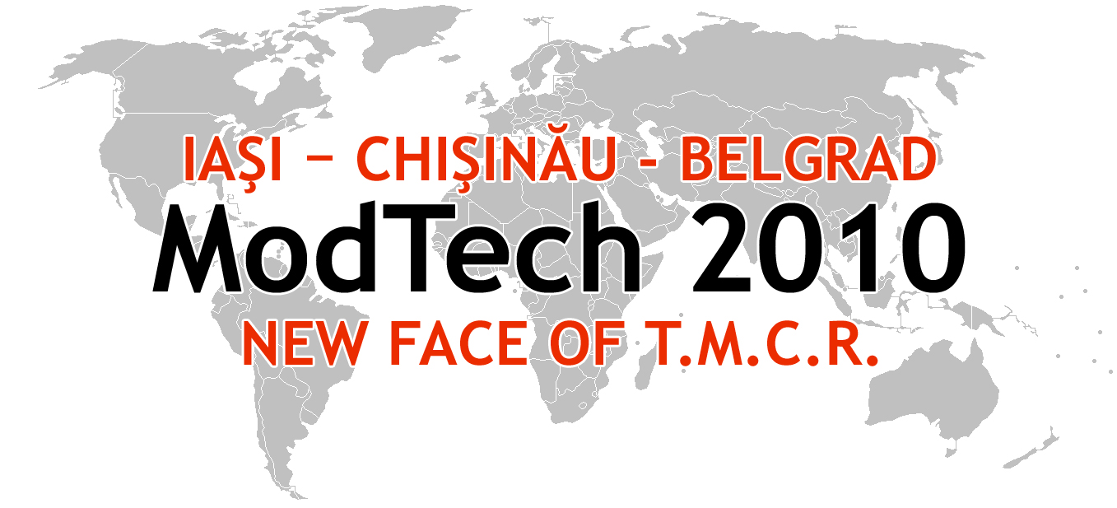

ModTech International Conference - New face of TMCR
Modern Technologies, Quality and Innovation - New face of TMCR
20-22th May 2010, Slanic-Moldova-Romania

ATTENDANCE
APPLICATION FORM

First name
Second name
Didactic position
Scientific position
Institution
Address
Phone
Mobile Phone
Fax
E-mail
Paper title/Papers titles
Conference sections attendance | 1-Micro and Nano Technologies  2-Manufacturing  3-Automation & Flexible Technologies  4-CAD/CAM/CAE/CAX Systems  5-Materials, Processes and Innovative Technologies  6-Project Management and Quality  7-Weldings and Non-Conventional Technologies  8-Forming Technologies
Number of persons

