International Journal of Modern Manufacturing Technologies 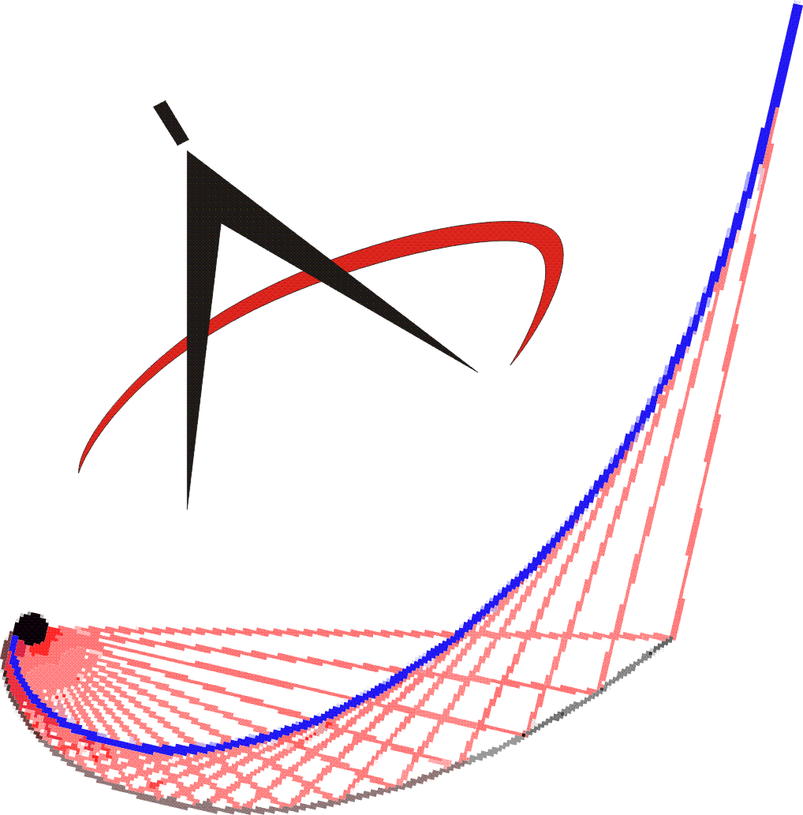
ISSN 2067-3604 - Vol. IV, No. 1 / 2012 http://www.modtech.ro

COPYRIGHT TRANSFER RELEASE FORM*

The author(s) hereby affirm that the manuscript bellow entitled is original and has not been published elsewhere and that it has not been submitted simultaneously to the other Conference or review for publishing.

The undersigned author(s) agree with the copyright transfer of the bellow paper titled to the International Journal of Modern Manufacturing Technologies.

Title of the Paper:

Full List of Authors:

First author** Email:

Address
(including the ZIP Code, City and Country) :

Date:

Signature:

*The Copyright Transfer Release Form, completed and signed by first author, must be submitted to International Journal of Modern Manufacturing Technologies before your paper can be considered for publication (before May 31, 2012 to 0040.232.217290 fax numbers or, if possible, after signing and scanning by email to modtech@tcm.tuiasi.ro).

** International Journal of Modern Manufacturing Technologies takes for granted that the first author signs this agreement on behalf of all the paper’s co-authors.

